Python DA Assignment 1
Data Analysis using NumPy and Pandas

NAME : UMAYAL.K
SUBMISSION DATE: 26 - 10 - 2026

OperationsNumpy Array:

1. Create a 1D NumPy Array:

- This creates a 1-dimensional NumPy array named temperatures_w1 containing the Week 1 temperature values.

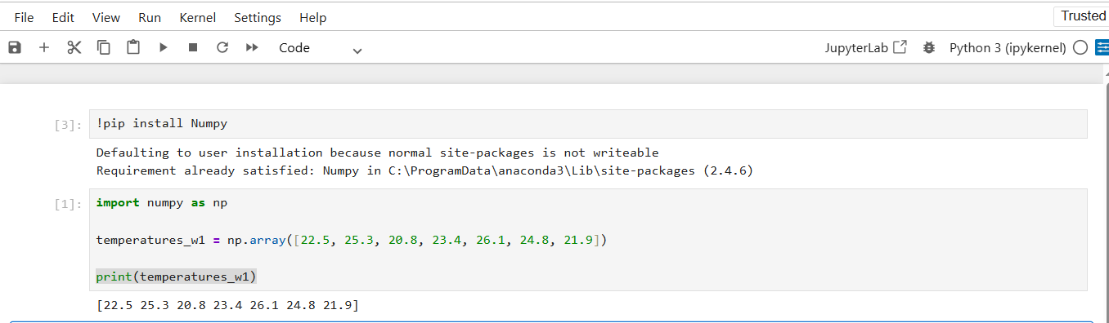

2. Inspection and Properties:

- (7,) means the array has 7 elements arranged in one dimension.
- The comma inside the parentheses indicates that it is a 1D array.

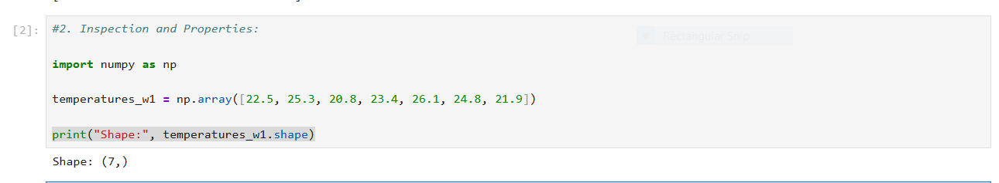

3. Array Operations:

3(1).Convert Celsius to Fahrenheit
Formula: Fahrenheit = (Celsius * 9/5) + 32
Fahrenheit =(22.5 * 9/5) +32 => 72.5

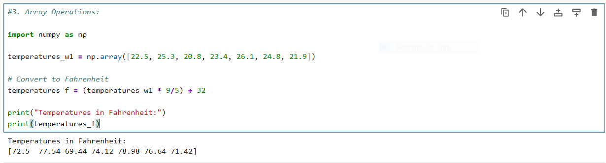

3(2).The maximum, minimum, and mean temperatures for the week:

- Maximum Temperature: 26.1 °C
- Minimum Temperature: 20.8 °C
- Mean Temperature: 23.54 °C (rounded to 2 decimal places)

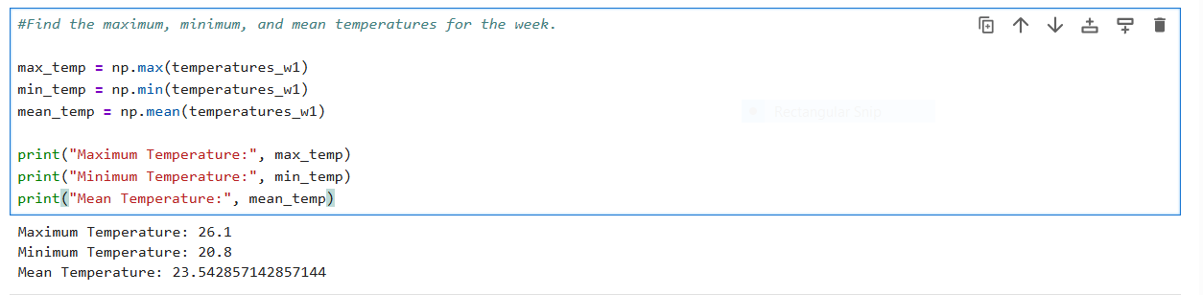

4. Array Slicing and Indexing:

- Extract the temperatures for the first three days of the week.
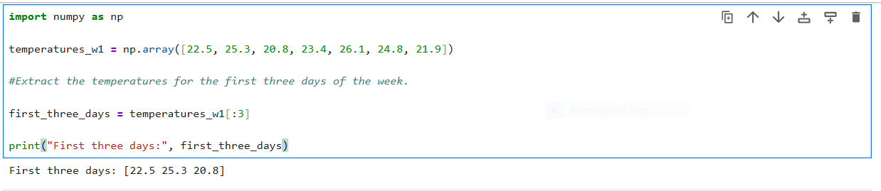

- Extract the temperatures for the weekend (last two days).

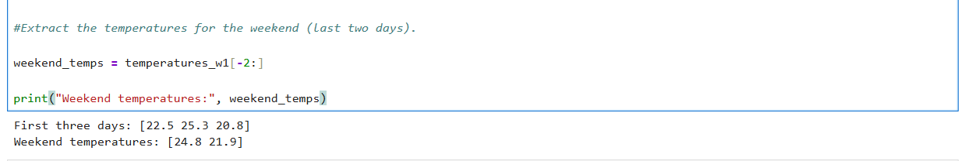

- Extract the temperatures for the middle three days of the week.

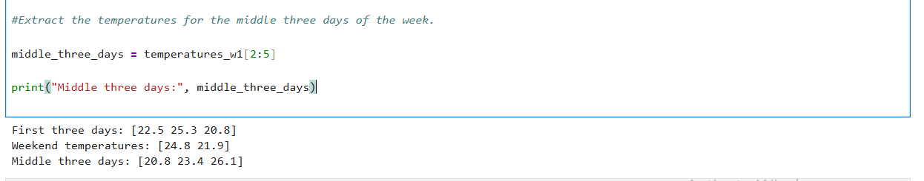

- These slices use NumPy indexing where the start index is included and the end index is excluded.

5. Create a 2D Array:
Create a 2D NumPy array named temperatures

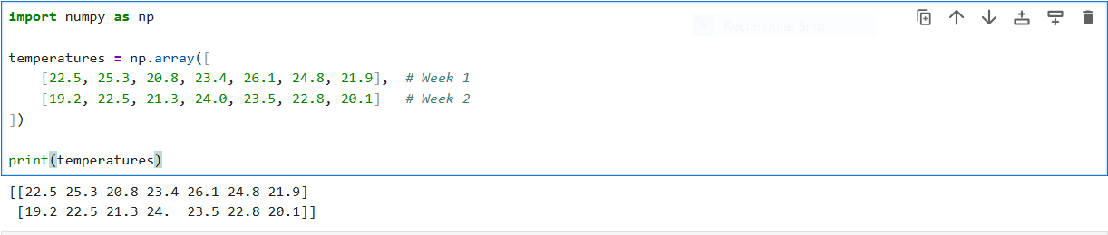

- 2 rows → Week 1 and Week 2
- 7 columns → 7 days in each week
- Shape (2, 7) means 2 weeks × 7 days of temperature data.

6. Inspect and Slice the 2D Array:

6(1).Inspect and print the shape, data type, and total number of elements in the
temperatures array.

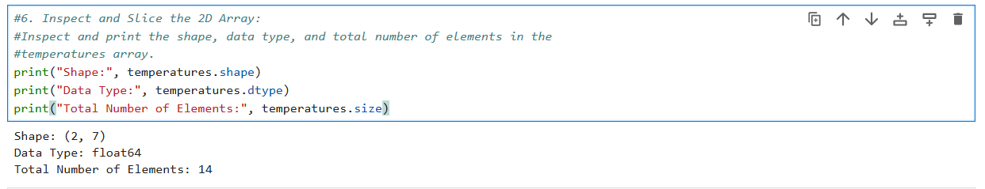

(2, 7) → 2 weeks and 7 days per week
float64 → decimal values are stored as floating-point numbers
14 → total elements = 2 × 7

6(2.a).Extract the temperatures for each week
Week1:
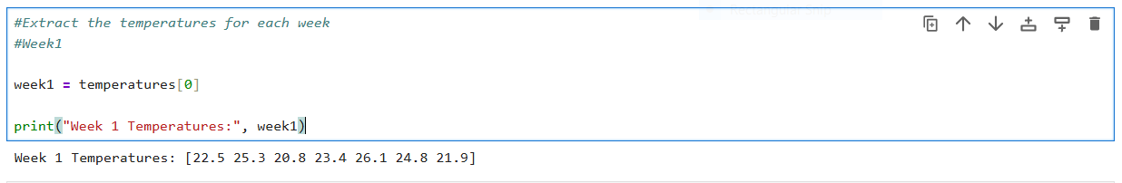

Week2:
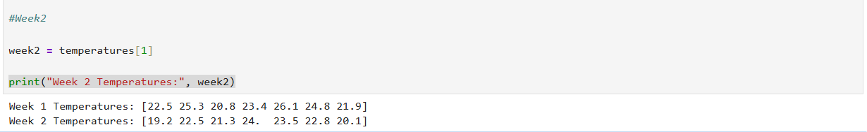

6(2.b).The weekends (last two days) for both weeks.

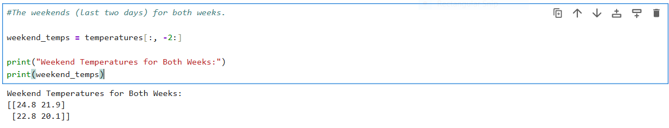

- Week 1: temperatures[0]
- Week 2: temperatures[1]
- Weekend temperatures for both weeks: temperatures[:, -2:]
- Array shape: (2, 7)
- Total elements: 14

Pandas Series:
1.Creating Pandas Series:
● Create a Pandas Series named marks with the following data:
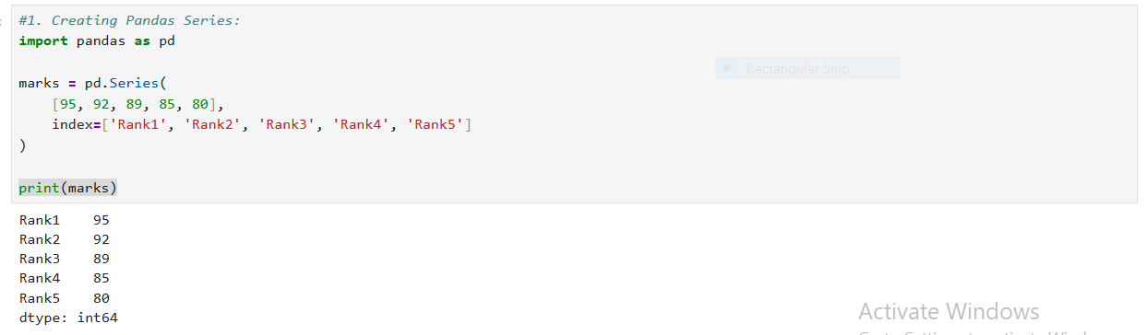
2. Indexing and Slicing:
2(1).The mark of the 1st rank student.
2(2).Use the loc accessor the top 3 ranks by specifying their index labels.
2(3).Use the iloc accessor to retrieve the mark of the 3rd rank student.
2(4).Apply a boolean mask to filter the Series and retrieve the ranks where the
marks are greater than 90.

- loc[] → label-based access
- iloc[] → position-based access
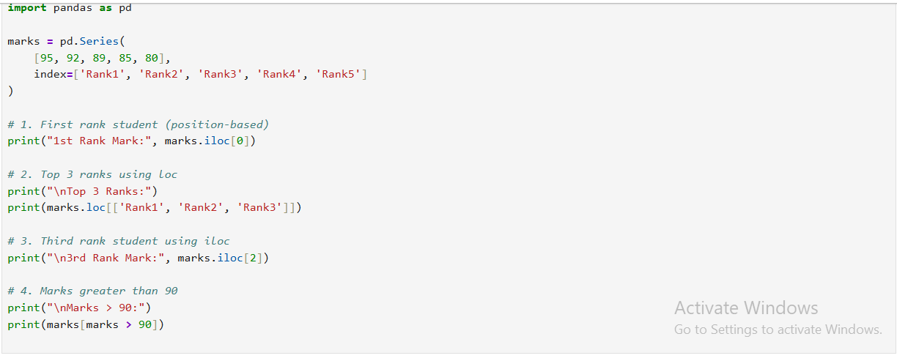

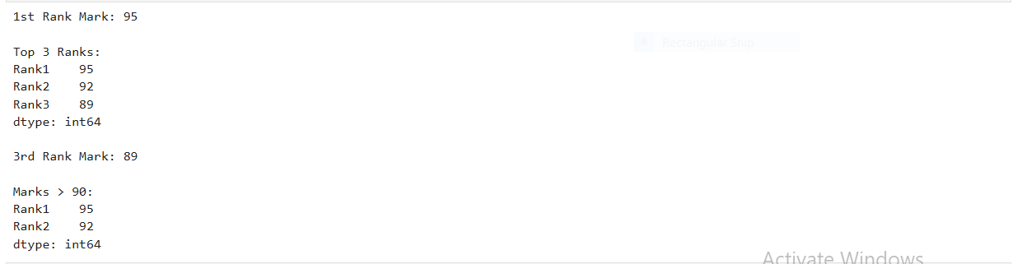

3. Manipulating Series:
3(1).Modify the mark of the student with the 1st rank to 100.
- marks['Rank1'] accesses the value associated with the label 'Rank1'.
- Assigning 100 replaces the old value (95).
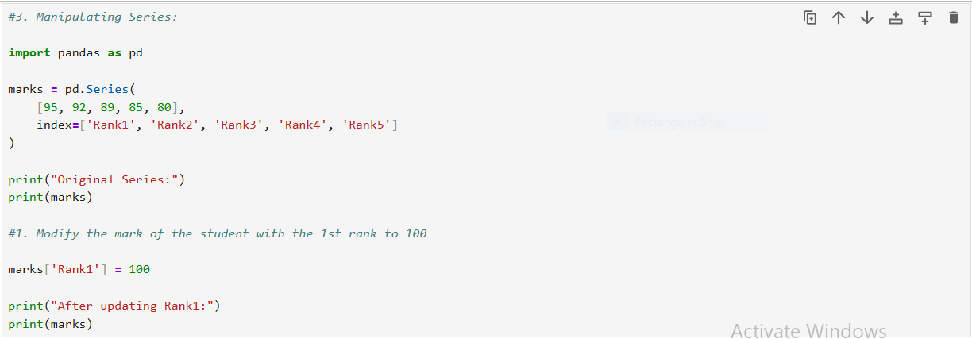

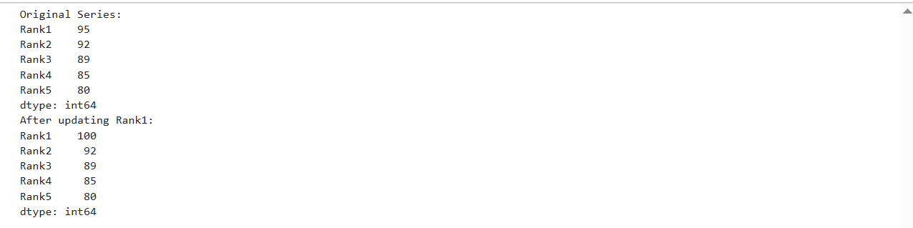

3(2).Remove the entry corresponding to the last rank from the Series.

- drop() removes the specified index label.
- 'Rank5' and its value (80) are deleted.
- Since drop() returns a new Series, we assign it back to marks.

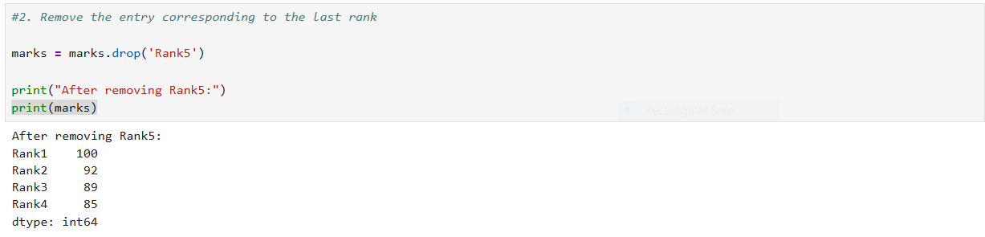

3(3).Compute the CGPA by dividing each mark in the Series by 10.

- Pandas performs vectorized operations, meaning the calculation is applied to every element automatically.
- 100 / 10 = 10.0
- 92 / 10 = 9.2
- 89 / 10 = 8.9
- 85 / 10 = 8.5
output:
- Rank1 10.0
- Rank2 9.2
- Rank3 8.9
- Rank4 8.5
- dtype: float64
- Notice the data type changes from int64 to float64 because division produces decimal values.

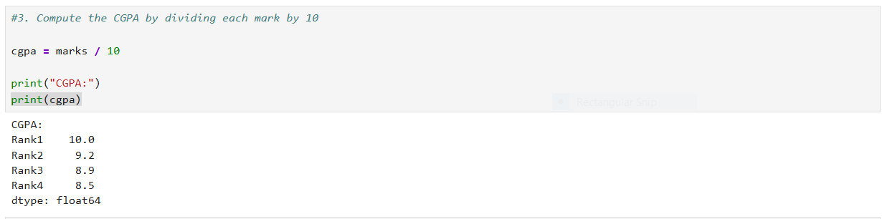

- series['label'] = value → Modify a value.
- series.drop('label') → Remove an entry.
- series / number → Perform arithmetic on all values in the Series at once.

Pandas DataFrame:
1. Creating Pandas DataFrame:
Create a Pandas DataFrame named transactions with the following data:

- 10 rows represent 10 transactions.
- 4 columns represent TransactionID, ProductCategory, Region, and Amount.

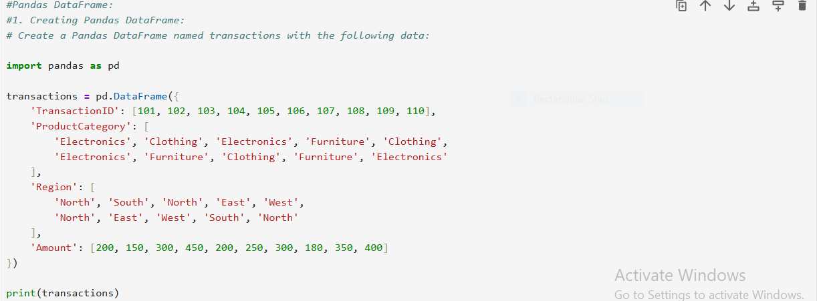
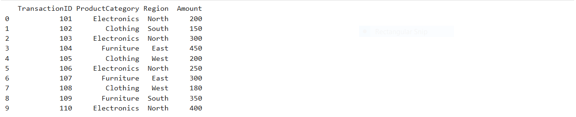

2. Data Exploration:
2(1).Display the transactions DataFrame and its basic information, including
head, tail, shape, column names, and data types.
2(1.a).Head (first 5 rows):

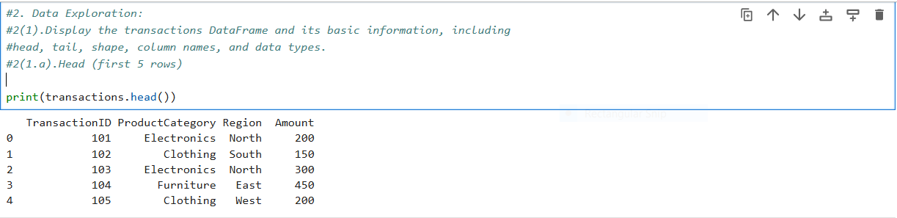

2(1.b).Tail (last 5 rows)

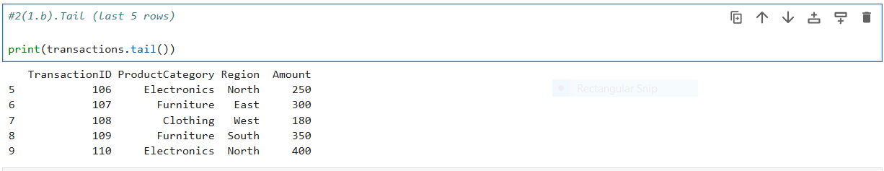

2(1.c).Shape

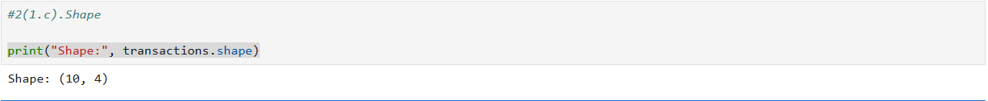

2(1.d).Column Names

2(1.e).Data Types

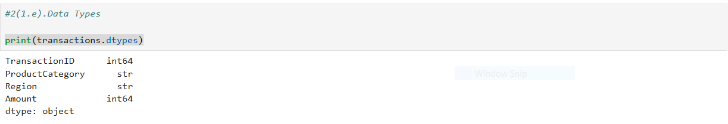

Complete Information

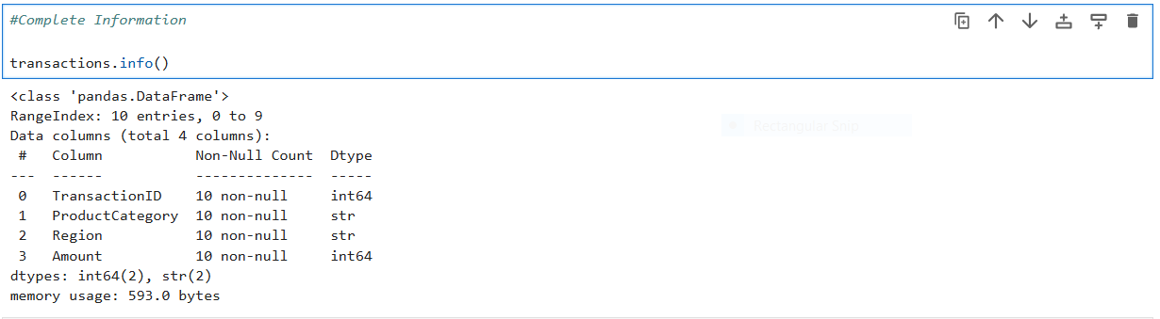

2(2).Display only the 'ProductCategory' and 'Amount' columns.

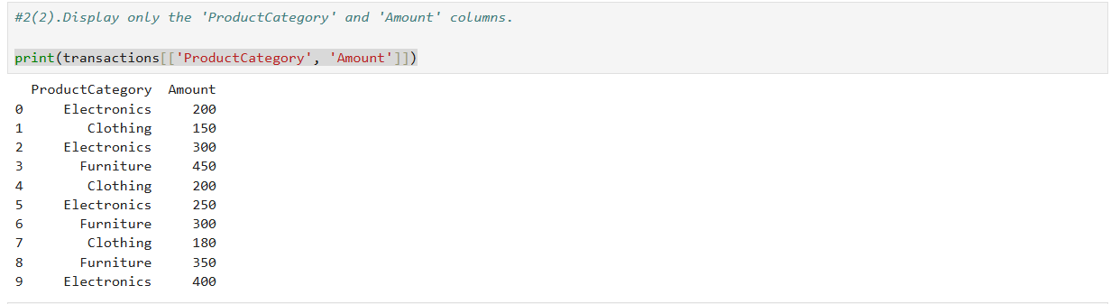

2(3).Retrieve the last 3 columns of the DataFrame using iloc or loc.

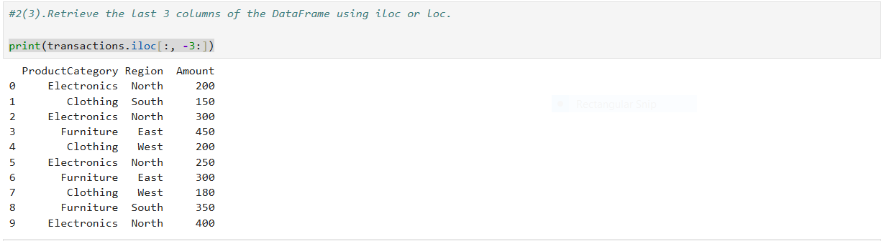

2(4).Filter rows where the 'Region' is 'North' and 'Amount' is greater than 200.

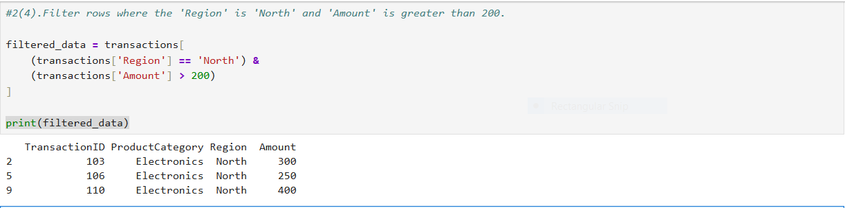

2(5).Find the value counts for the 'ProductCategory' column.

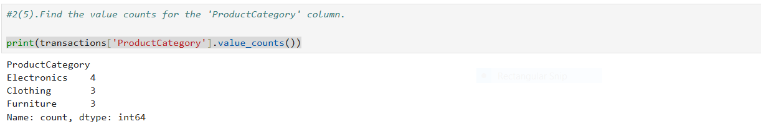

2(6).Find the unique values in the 'Region' column.

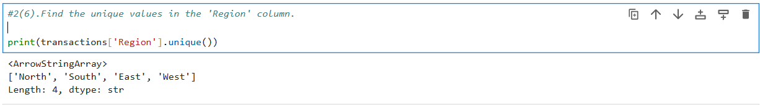

2(7).Group by 'Region' and find the mean amount for each region.

- East: (450 + 300) / 2 = 375.0
- North: (200 + 300 + 250 + 400) / 4 = 287.5
- South: (150 + 350) / 2 = 250.0
- West: (200 + 180) / 2 = 190.0

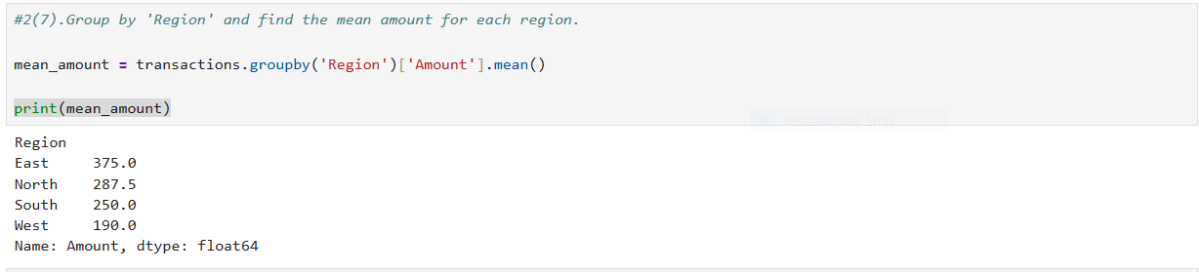

3. Manipulating the DataFrame:

3(1).Modify the 'Amount' for the transaction with TransactionID 102 to 165:

- transactions['TransactionID'] == 102 finds the row with TransactionID 102.
- loc selects that row and the Amount column.
- 165 replaces the old value 150.

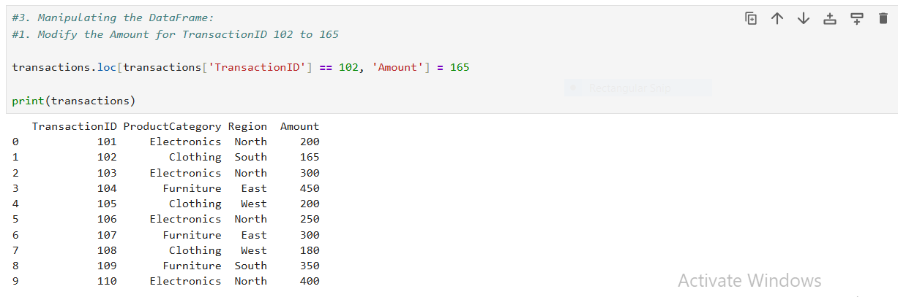

3(2).Add a new column 'Discount' by calculating 10% of the 'Amount'.

- Discount = Amount × 10%
- 200 × 0.10 = 20
- 165 × 0.10 = 16.5
- 300 × 0.10 = 30

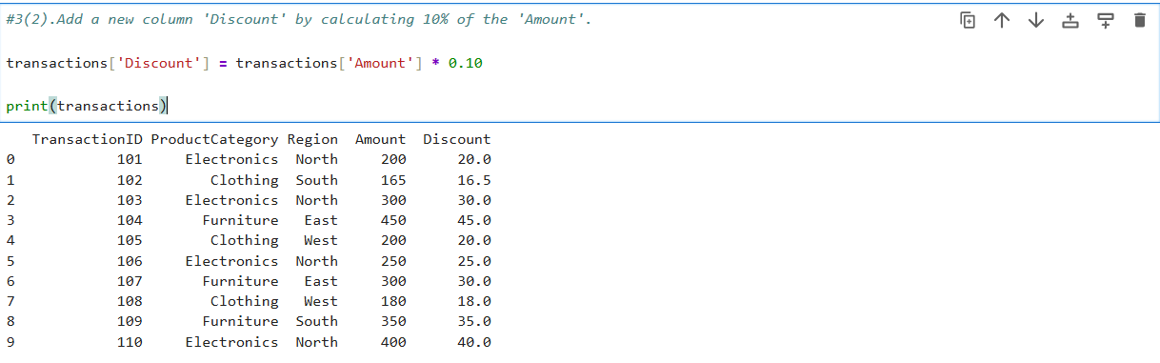

3(3). Remove the row with TransactionID 109:

- This keeps all rows except the one where TransactionID is 109.
- Removed row : 109 Furniture South 350

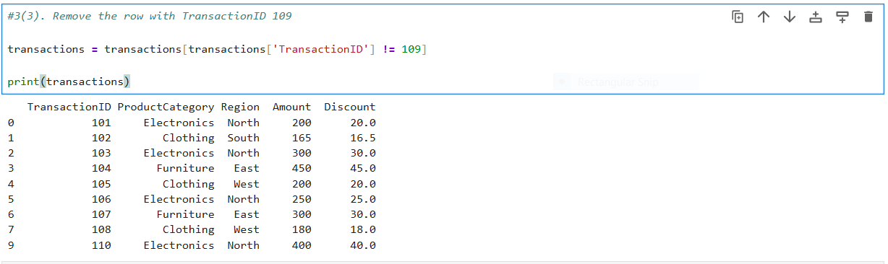

3(4). Delete the 'Discount' column:

- drop() removes a row or column.
- axis=1 means column.
- inplace=True updates the DataFrame directly.

Key Methods Used:
- loc[] → Update specific values.
- DataFrame['new_column'] = ... → Add a new column.
- Boolean filtering (!=) → Remove specific rows.
- drop(..., axis=1) → Delete a column.

